**Problem Solving**

**Difficulty Level: Easy**

**Problems:**

1. Check Whether a Given Number is Even or Odd

**Even Number:**  
A number is said to be an **even number** if it is completely divisible by 2.  
In other words, if a number is divided by 2 and leaves a remainder of 0, then it is said to be an even number.  
**Example:** 36, 24

**Odd Number:**  
A number is said to be an **odd number** if it is not completely divisible by 2.  
In other words, if a number is divided by 2 and the remainder is 1, it is said to be an odd number.  
**Example:** 21, 15

#include <stdio.h>

void checkEvenOdd(int num) {

if (num % 2 == 0)

printf("%d is an even number.\n", num);

else

printf("%d is an odd number.\n", num);

}

int main() {

int num;

printf("Enter a number: ");

scanf("%d", &num);

checkEvenOdd(num);

return 0;

}

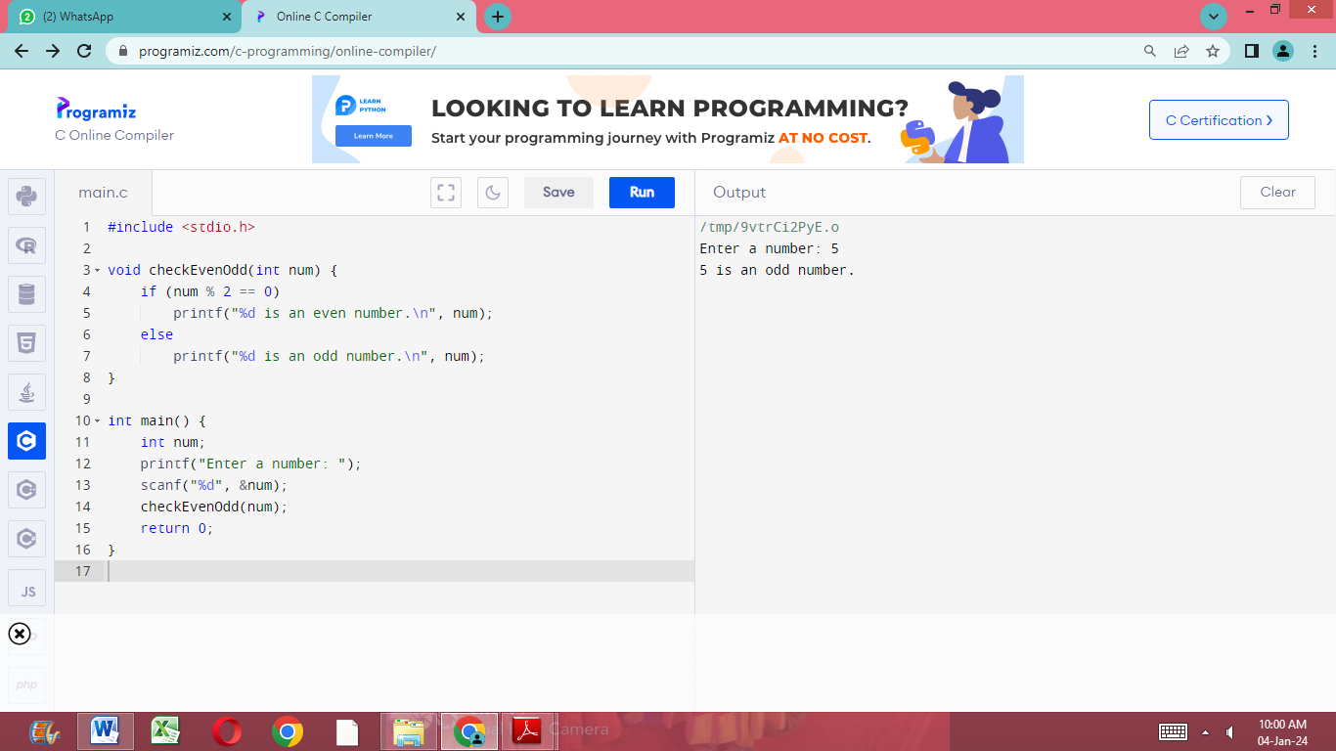

1. Find the Sum of Even and Odd Numbers

Problem Description:

The program takes the number N and finds the sum of odd and even numbers from 1 to N.

**#include<stdio.h>**

**int main(){**

**int n,I,even_sum=0,odd_sum=0;**

**printf("enter the value:");**

**scanf("%d",&n);**

**for(i=1;i<=n;i++){**

**if(i%2==0){**

even_sum+=i;

**}else{**

odd_sum+=i;

**}**

**}**

**printf("Sum of even numbers:%d\n",even_sum);**

**printf("Sum of odd numbers:%d\n",odd_sum);**

**return 0;**

**}**

1. Check Whether a Number is Positive or Negative

Problem Description:

The program takes the given integer and checks whether the integer is positive or negative.

**#include<stdio.h>**

**int main(){**

**int n;**

**printf("Enter an integer:\n");**

**scanf("%d",&n);**

**if(n<0){**

**printf("Number is Negative\n");**

**}else if(n>0){**

**printf("Number is positive\n");**

**}else{**

**printf("Number is zero");**

**}**

**return 0;**

**}**

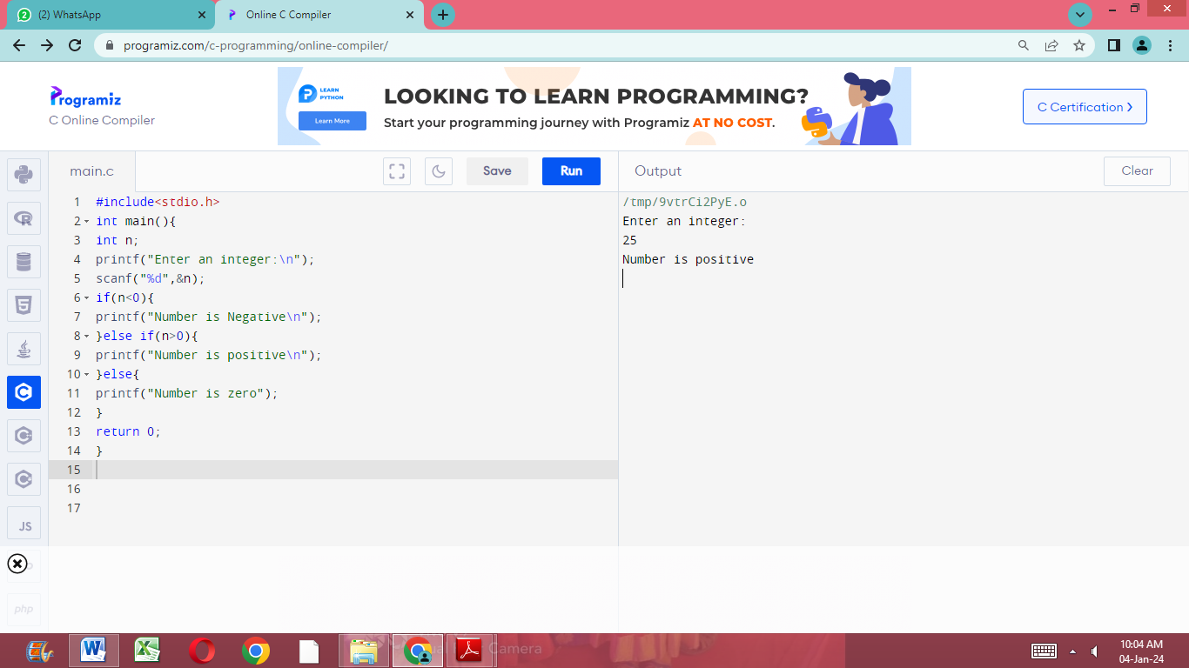

1. Find the Largest Number Among Three Numbers.

In C programming, the largest element of a number is the number with the highest numerical value of the three numbers.

For example, if three numbers are given, 1, 2, 3, the largest of the three numbers is 3.

Problem Description

Write a C program that takes the 3 numbers and finds the largest number Aamong three numbers.

**#include<stdio.h>**

**int main(){**

**int a,b,c;**

**printf("Enter the values of a,b,c:\n");**

**scanf("%d %d %d",&a,&b,&c);**

**if(a>b&&a>c)**

**printf("A is greater\n",a);**

**else if(b>a&&b>c)**

**printf("B is greater\n",b);**

**else**

**printf("C is greater\n",c);**

**return 0;**

**}**

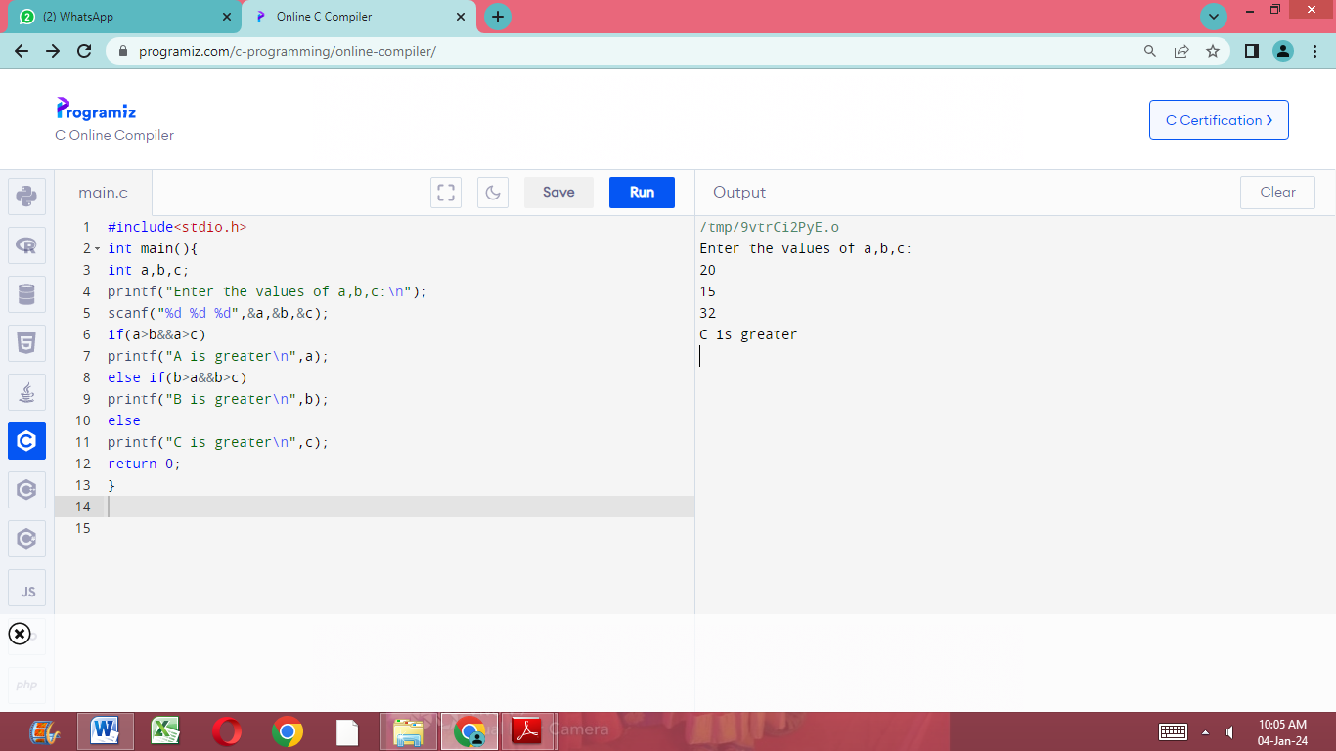

1. Swap Two Numbers

Swapping two numbers in C programming means swapping the values of two variables. For example, there are two variables m & n. Value of m is “2” & value of n is “3”.

Before Swapping: m value = 2; n value = 3

After Swapping: m value = 3; n value = 2

**#include<stdio.h>**

**int main()**

**{**

**int a,b,temp;**

**printf("enter two numbers:\n");**

**scanf("%d %d",&a,&b);**

**printf("Before swapping: a=%d,b=%d\n",a,b);**

**temp=a;**

**a=b;**

**b=temp;**

**printf("After swapping: a=%d,b=%d",a,b);**

**return 0;**

**}**

**Output**

